
2023年招收攻读硕士学位研究生入学考试试题A卷
********************************************************************************************
招生专业与代码：英语语言文学（050201），外国语言学及应用语言学（050211）

考试科目名称及代码：外语（英）水平考试 考试科目代码：[706]
考生注意：所有答案必须写在答题纸（卷）上，写在本试题上一律不给分。
Part I. Grammar and Vocabulary (30 points)

Directions: There are 30 incomplete sentences in this section. For each sentence there are 4 choices marked A, B, C and D. Choose the one that best completes the sentence and write your answer on the ANSWER SHEET.
1. The suspect was _________ of the crime when he was found “not guilty” by the court.
A. adjourned B. acquitted C. ambushed D. appeased
2. But the medication produced _________ and I felt constantly on the verge of nausea.
A. lark B. ledge C. lassitude D. loiter
3. Heavy rainfall in the south of England means that flooding is____.
A. imminent B. momentous C. transient D. prospective
4. Mrs. Hartley has a habit of asking questions ________.
A. but then not to listen to the answers
B. and then not listen to the answers
C. and then not listening to the answers
D. and then doesn’t listen to the answers
5. When the rage had passed and he had come to himself, he would show a deep ______ and agree humbly to any punishment it was proposed to inflict on him.
A. penitence B. perfidy C. perjury D. pillage
6. Heredity accounts for 50% to 60% of a woman’s ________ to alcoholism, about the same as for men.
A. devastation B. vulnerability C. pharmacy D. fibrosis
7. The murder of young children was a _______ crime and should be punished severely.
A. hoarse B. hectic C. haughty D. heinous
8. The floor is an________ white, almost beautiful, and—most important—empty.
A. immaculate B. immense C. impregnable D. impartial
9. The greatest obstacle to economic and environmental improvements in the developing countries is their __________ foreign debts.
A. reminiscent B. degenerative C. mammoth D. ethical
10. It seems that all those subway tokens became_______ when New York started using magnetic cards instead.
A. obsequious B. obsolete C. odious D. ostensible
11. They _______ their weekends in the suburb.
A. nearly always spend B. nearly are always spending
C. spend nearly always D. nearly always are spending
12. However, people remained concerned about the high cost of food and other goods due to ______ inflation.
A. radical B. remorseful C. rampant D. remunerated
13. Doctors consider going to bed early to be more healthful __________.
A. than to stay up late B. than staying up late
C. to staying up late D. than staying up late
14. Several times a day in a lab in the Swedish city of Linköping, road accidents are______ and the consequences are analyzed.
A. simulated B. slandered C. smeared D. snubbed
15. Fear, whether due to a ________ work environment, jealous co-workers, or your personal insecurity, does not enhance performance.
A. tipsy B. treacherous C. temporal D. tangible
16. General Motors, once regarded as an E.V. leader among traditional carmakers, was _________track last year by a recall of its electric Bolt.
A. kicked off B. turned off C. cut off D. knocked off
17. The sphere was constructed from five concentric rings, each inscribed with ________
symbols—the bull, the scorpion, et cetera—and seemingly random numbers and letters.
A. zephyr B. zodiac C. zyme D. zest
18. The bullets rain over, they are not fired ____________, but shrewdly aimed from all
sides.
A. haphazard B. odious C. haughty D. handicapped
19. __________ the financial means to remain independent, Thomas Edison was compelled to seek employment as a night telegraph operator.
A. He was deprived of B. Deprived of
C. That he was deprived of D. Although he was deprived of
20. Five minutes later, Zoe had me outfitted in a _______ flannel shirt and jeans three sizes too big, bright red sneakers, and a floppy rainbow hat.
A. oozed B. ragged C. mopped D. mocked
21. Soon, a sweet smoke ___________ through the air and into its nostrils.
A. intercepted B. detested C. saturated D. wafted
22. When Joe needs a tall ladder, he will borrow ____________.
A. his neighbor ladder B. ladder of his neighbor’s
C. that of his neighbor’s D. one from his neighbor
23. Recognizing ill intentions and _______ motives in others can be difficult for us.
A. ulterior B. stationary C. vulgar D. toxic
24. The law also expanded the payments to families with low or no income, providing financial ______ for families, many still reeling from flood-related job losses.
A. tornado B. salvation C. delinquency D. momentum
25. The imagination is important, as it allows us to ______all kinds of possibilities in the future and to understand the past in a way that has real survival value.
A. speak of B. complain of
C. conceive of D. approve of
26. Securities and Exchange Commission's website has a warning that________ can use
social media “to appear legitimate, to hide behind anonymity, and to reach many people
at low cost.”
A. splinters B. sponsors C. swindlers D. successors
27. Moderna, which has made billions of dollars from a COVID-19 vaccine based on messenger RNA technology, last week accused its main rival of ______ the company’s patents for a similar mRNA shot.
A. wading B. invoking C. muffling D. infringing
28. With the introduction of the electronic computer, there is no complicated problem _______ can be solved in a few hours.
A. that B. which C. but D. what
29. While the new model may have proved capable of _________ human odor perception when given single molecules, it would not fare so well in the real world.
A. embroidering B. rigging C. yelping D. mimicking
30. Yet the research on liver transplants and survival rates for cannabis users is frustratingly _____.
A. scribbled B. scrumptious C. sedate D. scant

Part II. Cloze (20 points)
Directions: There are 20 blanks in the following passage. Decide which of the choices given below would best complete the passage if inserted in the corresponding blanks. Write your answers on the ANSWER SHEET.

Humans are lucky to live a hundred years. Oak trees may live a thousand; mayflies, in their adult form, a single day. But they are all alive in the same way. They are 1 cells which embody flows of energy and stores of information. Their metabolisms make use of that energy, 2 it from sunlight or food, to build new molecules and break down old ones, using mechanisms described in the genes they 3 and may, or may not, pass on.
It is this endlessly repeated, never quite perfect 4 which explains why oak trees, humans, and every other plant, fungus or single-celled organism you have ever seen or felt the 5 of are all alive in the same way. It is the most fundamental of all family resemblances. Go far enough 6 any creature’s family tree and you will find an ancestor that sits in your family tree, too. Travel further and you will find 7 scientists call the last universal common 8 , luca. It was not the first living thing. But it was the one which 9 the life that exists today.
And then there are viruses. In viruses the 10 between metabolism and genes that binds together all life 11 you are related, from bacteria to blue whales, is broken. Viral genes have no cells, no bodies, no metabolism of their own. The 12 particles, “virions”, in which those genes come packaged—the dot-studded disks of coronaviruses, the sinister, sinuous windings of Ebola, the bacteriophages with their science-fiction landing-legs that 13 microbes—are entirely inanimate. An individual animal, or plant, embodies and maintains the 14 metabolism that made it. A virion is just an arrangement of matter.
The virus is not the virion. The virus is a process, not a thing. It is truly alive only in the cells of others, a virtual organism 15 borrowed hardware to produce more copies of its genome. Some bide their time, letting the cell they share the life of 16 . Others immediately set about producing enough virions to split their hosts from stem to stern.
The virus has no plan or 17 . The simplest purposes of the simplest life—to maintain the difference between what is inside the cell and what is outside, to 18 one chemical or away from another—are entirely beyond it. It copies itself in whatever way it does simply because it has copied itself that way before, in other cells, in other hosts.
That is why, asked whether viruses are alive, Eckard Wimmer, a chemist and biologist who works at the State University of New York, Stony Brook, offers a yes-and-no. Viruses, he says, “ 19 between nonliving and living phases”. He should know. In 2002 he became the first person in the world to take 20 nonliving chemicals and build a virion from scratch—a virion which was then able to get itself reproduced by infecting cells.

1. A. made from | B. made for | C. made up of | D. made use of
2. A. being | B. to be | C. been | D. be
3. A. inherited | B. influence | C. indicate | D. in
4. A. motion | B. reproduction | C. generosity | D. blessing
5. A. presence | B. wildness | C. preference | D. regard
6. A. of | B. in | C. up | D. with
7. A. what | B. that | C. which | D. where
8. A. attendant | B. avenger | C. ancestor | D. ancillary
9. A. adjust into | B. adapt to | C. set the seal on | D. set the template for
10. A. operation | B. link | C. eternity | D. disease
11. A. in which | B. for which | C. to which | D. as which
12. A. hearty | B. tiny | C. hostile | D. prudent
13. A. take over | B. dig out | C. sponge down | D. prey on
14. A. restless | B. enlightened | C. fascinated | D. relentless
15. A. running to | B. running at | C. running against | D. running on
16. A. live on | B. living on | C. live at | D. living at
17. A. argue | B. desire | C. gather | D. deny
18. A. move towards | B. move on | C. move against | D. move over
19. A. separate | B. alternate | C. balance | D. differentiate
20. A. a way of | B. a kind of | C. an array of | D. a sort of

Part III. Reading Comprehension (30 points)

Directions: In this section, there are three passages followed by questions or unfinished statements, each with four suggested answers marked A, B, C, and D. Choose the best answer and write the letter of your choice on the ANSWER SHEET.
Questions 1–5 are based on the following passages.

Passage 1 is adapted from James Platt, Poverty, originally published in 1884. Passage 2 is adapted from Will Reason, Poverty, originally published in 1909. As societies became more industrialized and urban in the late nineteenth century, discussions arose regarding the root causes of poverty.
Passage 1
The aim of charitable persons should not be so much the giving with money in hand, or religious teaching on their lips, as the sympathetic, friendly intercourse of man with man, woman with woman, irrespective of class, and actuated by the desire to stimulate hope and energy, and to show the lowest outcast that the world, even to them, may be made more enjoyable, if they have the desire to live a life more in harmony with the better part of their nature; and so in time, by degrees, as the child is taught to walk, step by step, we may improve the lowest types of humanity.
To obtain better dwellings for the poor, it is essential for the poorer class to feel a want for, and a desire to have, houses better, cleaner, and more wholesome than those they now inhabit. Too many, at present, wantonly and maliciously, but more frequently, through neglect and apathy, injure the houses in which they live. Many of them prefer to be uncomfortable.
The man or men that are wanted to solve this difficult question, the only true or real reformers, will be those who study how to alter the character, estimate of life, the ideal of existence amongst the poor. From the clergy of all denominations, from every man who has influence over the masses, we want the moral courage to tell the poor not to marry until they are in a position to support a wife and family, to be reasonably industrious, uniformly thrifty, and unswervingly sober. The real reformer, the only savior of society, is the man who will tell the poor how they may become less so, by teaching them how to earn more or spend less, not by robbing others of what they have.
We must raise the status of the poorer class, improve their individuality, give them a higher character, and thus prepare the way for a well-working humanity that should result in well-working institutions. We must regenerate the entire social fabric, through the working of juster laws, purer aims, nobler instincts—through individual cooperation of the many, as one, in contributing to the welfare of all.
Passage 2
It is clear, therefore, that the readjustment of distribution must be effected through a readjustment of the ownership and management of the essential factors of production. It is not possible to effect this readjustment on the basis of unrestricted competition, because in the case on the prime factor of production, the land monopoly is caused, not by any artificial arrangement, but by the simple natural fact that it is essential and restricted in quantity. The only course that remains is to find some way of democratizing the monopoly value, so that everyone benefits by his due share of what has not been made by the industry of any and is indispensable to the industry of all.
This cannot be effected by parceling it out to individuals, for very obvious reasons. It would have to be continually redistributed, it would be impossible to equate the value of the different parts, and such distribution would destroy its productive efficiency.
We therefore must look to some means of collective ownership and use of these natural forces, and also of all the value that accrues not from individual energy, industry or skill, but from the conditions which society itself affords. “To deal with causes we must strike at the error of distribution, by gradually substituting public ownership for private ownership of the means of production. In no other way can we secure for each worker in the hive the full reward of his labor. So long as between the worker and his just wage stands the private landlord and the private capitalist, so long will poverty remain, and not poverty alone, but the moral degradations which inevitably arise from the devotion of labor to the service of waste,” writes L.G. Chiozza in “Riches and Poverty.”
Here we touch the greatest controversy of the present time, and another volume would be needed to examine all the reasons for and against such a social adjustment. But it is clear that unless some way of effecting it is found, consistent with fairness to all, poverty, undeserved and unavoidable, must be the lot of many, while equally undeserved income will continue to be reaped, without conscious or intentional fraud on their part, by many others. As the poverty reacts on the character for ill effect, so also it is to be feared that the unearned riches also produce qualities, of a different and more subtle nature, but equally inimical (不利的) to the true well-being both of the individuals concerned and of the community.

1. In Passage 1, Platt suggests that one way a society can reduce poverty is to
A. provide in-demand technical training to citizens in need of marketable skills.
B. redistribute wealth directly from certain types of rich men.
C. teach that the benefits of budgeting outweigh the benefits of handouts.
D. instruct children in financial matters from a young age.
2. In Passage 2, Reason implies that evenly distributing wealth and property among individuals would have what consequence?
A. Neither the rich nor the poor would reap benefits.
B. All parties to the economy would improve their position.
C. The rich would take advantage to create their own monopolies.
D. The poor would be able to purchase property at decreased value.
3. Reason in Passage 2 would most likely characterize the position taken by Platt in the underlined sentence (“Many of . . . uncomfortable”) as
A. an accurate description of the root cause of the current economic situation of the poorer class.
B. a flawed assumption that generalizes the negative behavior of a few.
C. a surprising but realistic statement consistent with the economic trends of the times.
D. an offensive characterization of the rich that is not applicable to other classes of society.
4. Both authors would most likely agree that any social changes undertaken to fight poverty would be
A. likely to completely solve the problems of financial inequality.
B. a stopgap measure needed to prevent the wealthy from keeping their money.
C. unsuccessful without a drastic change in the mindset of the poor.
D. partial solutions that would present new sets of challenges.
5. Which choice best describes the way the two authors characterize effective ways to reduce poverty?
A. Platt believes that financial education is the key to reducing poverty in a society, while Reason believes that financial education is irrelevant if individuals do not participate.
B. Platt believes that poverty will be reduced only if those who are poor truly desire to lift themselves out of poverty, while Reason believes that poverty will be reduced only if society’s wealth is redistributed.
C. Platt believes wage regulation from major industry is a step in the right direction, while Reason believes that such regulation will be ineffective.
D. Platt believes training clergy to minister to the poor is the most effective way of improving the lives of those in poverty, while Reason believes that unearned riches are a necessary feature of a society.

Questions 6–10 are based on the following passage and supplementary material.
This passage is excerpted from Dan Glass, “What Happens if GPS Fails?” ©2016 by The Atlantic.
Despite its name, the Global Positioning System is not about maps; it’s about time. Each satellite in the constellation (24 are needed, plus the U.S. has several spares) has multiple atomic clocks on board, synchronized with each other and to Coordinated Universal Time (UTC)—the time standard used across the world—down to the nanosecond. The satellites continually broadcast their time and position information down to Earth, where GPS receivers in equipment from iPhones to automated tractors acquire signals and use the minuscule differences in their arrival time to determine an exact position.
While GPS was initially conceived to aid navigation, globally synchronized time is now a much more critical function of the system. Telecom networks rely on GPS clocks to keep cell towers synchronized so calls can be passed between them. Many electrical power grids use the clocks in equipment that fine-tunes current flow in overloaded networks. The finance sector uses GPS-derived timing systems to timestamp ATM, credit card, and high-speed market transactions. Computer network synchronization, digital television and radio, Doppler radar weather reporting, seismic monitoring, even multi-camera sequencing for film production—GPS clocks have a hand in all.
What if all these flying clock radios were wiped out, and everything on the ground started blinking 12:00? According to Mike Lombardi, a meteorologist at the National Institute for Standards and Technology, “Nobody knows exactly what would happen.” Since so many of these technologies were designed specifically with GPS in mind, the unsettling truth, he says, is “there’s no backup.”
The bulk of a more promising, comprehensive backup system already exists, right here on the ground. After the sextant (六分仪) but before GPS, navigators around the world used Long Range Aids to Navigation, or “LORAN,” a terrestrial system of transmitters and receiving equipment first developed during WWII. By the mid-1990s, Loran “tower chains” provided coverage for North America, Europe, and other regions in the Northern Hemisphere. Its use declined in favor of the much finer accuracy of GPS after it became available for civil use in 1995, but the U.S. Coast Guard continued working on an improved system using the existing infrastructure. If adopted, “Enhanced” LORAN, or eLoran, could provide positioning accuracy comparable to GPS. Broadcast at hundreds of thousands of watts, the signal is virtually un-jammable, and unlike GPS, can even be received indoors, underwater, and in urban or natural canyons. It also turns out that eLoran can provide a UTC time signal with sub-microsecond time resolution across a large geographical area.
The technology is available—the Coast Guard demonstrated a working prototype last year— so why isn’t America using it? John Garamendi, a California congressman, asked this question at a July 2015 congressional hearing on the Federal Radio-navigation Plan, the nation’s primary planning document for position, navigation, and timing (PNT). “There are two kinds of time,” he opened, “real time … and then federal time, which seems to be the forever time. The eLoran system was identified as a backup 15 years ago, and here we are, federal time, not yet done.”
Why is the sense of urgency among decision makers so out of sync? Could some of it be similar to why people delay backing up their computers even though they’ve been telling themselves to for weeks? How do we decide, when presented a risk with unknown odds, when it’s time to sacrifice time and resources to prevent it?
Now is a critically important time to answer that question, as the world has actually been given odds on another, even more catastrophic risk than GPS failure: destruction of the electrical power infrastructure itself. On July 23, 2012, a billion-ton cloud of electrified gases blasted off the far side of the sun at over six million miles per hour. According to professor Daniel Baker at University of Colorado, this coronal mass ejection (CME) “was in all respects at least as strong as the 1859 Carrington Event,” referring to the strongest solar storm ever recorded, which set fire to telegraph stations and caused auroras down to Cuba. As was widely reported two years ago, if the 2012 CME had occurred one week later, it would have hit Earth.
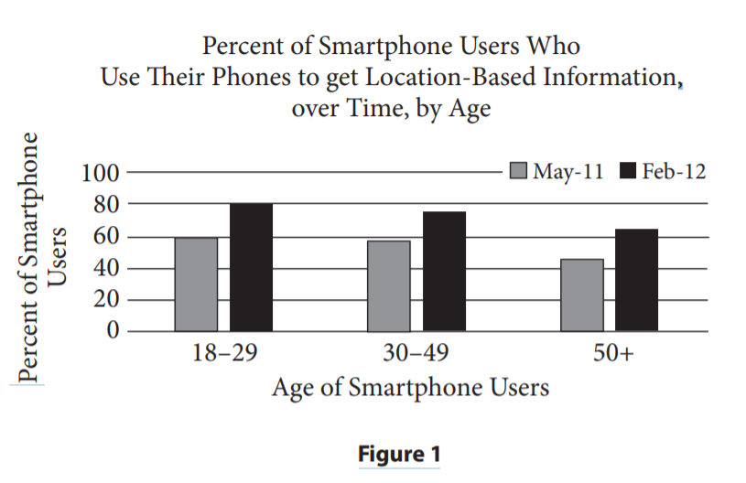
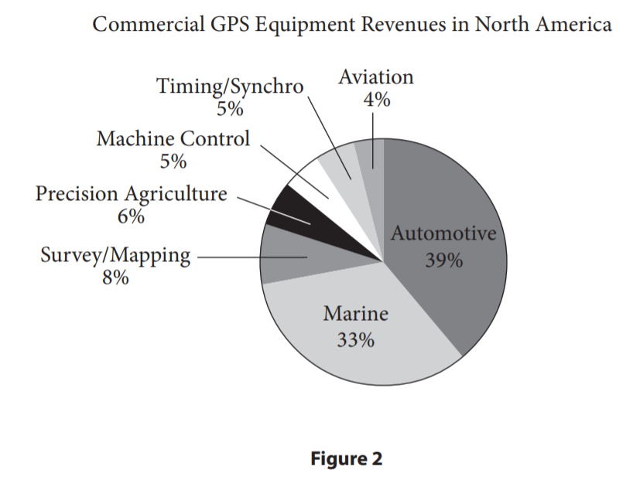

6. The main purpose of the passage is to
A. present a problem with a current technology and highlight a potential solution.
B. provide an overview of how clocks and satellites determine distance and location.
C. analyze the negative impacts of certain technologies across various industries.
D. praise developers for their ability to answer the hard questions.
7. Which of the following best characterizes Lombardi’s attitude toward “flying clock radios”?
A. He is confident about their ability to handle a multitude of tasks.
B. He is concerned about how they will interact with the eLoran systems.
C. He is annoyed that no one knows exactly how they work.
D. He is worried that they have no replacement systems in case of emergency.
8. According to John Garamendi, the reason America isn’t using the eLoran system even though the technology is available is that
A. the system doesn’t use real time.
B. government approval takes longer than the development of the technology.
C. federal decision-makers are scared to change systems.
D. solar storms threaten the system.
9. According to Figure 1, which group is closest in percentage to the percentage of users 18–29 in May 2011 who got location-based information on their smartphones?
A. Ages 50+ in Feb 2012
B. Ages 50+ in May 2011
C. Ages 30-49 in Feb 2012
D. Ages 18-29 in Feb 2012
10. Which statement is supported by Figure 2?
A. Less than a third of North American GPS revenue comes from the Automotive industry.
B. GPS revenues for Surveying/Mapping are less than GPS revenues for Precision Agriculture.
C. GPS devices are less important for the Aviation industry than they are for the Marine industry.
D. The Automotive and Marine industries make up a greater percentage of North American GPS revenues than the rest of the industries combined.

Questions 11–15 are based on the following passage.
This passage is excerpted from Joshua Hammer, “The Dying of the Dead Sea.” ©2005 by Smithsonian Magazine.
A refuge over the millennia for messiahs, martyrs and zealots, the Dead Sea region abounds with sites sacred to Islam, Christianity and Judaism. Some Muslims believe that Moses, whom they regard as a prophet, lies buried in a hilltop mosque just off the main road from Jerusalem. Jesus Christ was said to have been baptized in the Jordan River after traveling down to the Dead Sea from Galilee. And despite its name, the Dead Sea helps support one of the world’s most complex and vibrant ecosystems. Fed by fresh water springs and aquifers, a half-dozen oases along the shore harbor scores of indigenous species of plants, fish and mammals, including ibex and leopards. About 500 million birds representing at least 300 species, including storks, pelicans, lesser spotted eagles, lesser kestrels and honey buzzards, take refuge here during a biannual great migration from Africa to Europe and back again. Ein Feshka, a lush expanse of tamarisk, papyrus, oleander and pools of crystal water, was used by the late king Hussein of Jordan as a private playground in the 1950s and early ’60s. But as the Dead Sea recedes, the springs that feed the oases are moving along with it; many experts believe that Ein Feshka and other oases could wither away within five years.
One reason for the decline, according to environmentalists and various government officials, is a water policy on the part of Israel, Jordan and Syria that encourages unrestricted agricultural use. From the first years of Israel’s existence as a Jewish state, for example, when collective farming transformed much of it into fertile vineyards and vegetable fields, both Labor and Likud governments have bestowed generous water subsidies on the nation’s farmers. The results have been disastrous: today, agriculture accounts for just 3 percent of Israel’s gross national product and uses up to half of its fresh water. Recently, Uri Sagie, chairman of Israel’s national water company, told a conference of Israeli farmers that a growing and irreversible gap between production and consumption looms. “The water sources are being depleted without the deficit being restored,” he warned. Jordan lavishes similar water subsidies on its farmers with similar consequences: the kingdom takes about 71 billion gallons of water a year from the Yarmouk River and channels it into the King Abdullah Canal, constructed by USAID in the 1970s to provide irrigation for the Jordan Valley; Syria takes out another 55 billion gallons. So what is the answer?
Environmental activists say that one solution is to eliminate the water subsidies altogether. “Unless water is priced at its real costs,” says Ra’ed Daoud, managing director of ECO Consult, a water-use consulting firm, “there’s no way you’re going to reduce agriculture.” But because the region’s agricultural lobby is strong and the environmental movement weak, says Daoud, there has been insufficient leverage for change. Israel’s water commissioner, Shimon Tal, recently spoke publicly about the need to reduce some subsidies, but he admitted that it would be a long and difficult battle. Another approach is to encourage alternate water sources. Friends of the Earth Middle East is part of a coalition of 21 environmental groups that has developed proposals to conserve household water use (about 133 billion gallons a year, as much as that used in agriculture) and to regulate the amount that can be taken out of Israel’s springs. In addition, the Israeli government is promoting the building of wastewater treatment plants and desalination facilities; the first large one on the Mediterranean was completed this past August. Over the next five years, the government says, these facilities will provide as much as 106 billion gallons of fresh water annually for agricultural and domestic consumption.
Friends of the Earth is also taking its message to the farmers themselves—encouraging them to plant crops that use less water and spelling out the advantages of renewed tourism in the area. “Israeli agriculture is incredibly mismanaged,” Friends of the Earth director Gidon Bromberg says. “The farmers here could be planting olives, flowers and other crops like dates that don’t require fresh water. They could be using treated sewage water and allow fresh water to flow back into the Jordan River.” Friends of the Earth cites a Haifa University study that argues that current uses of the Jordan River make no sense. “The potential tourism-dollar return of a healthy river and a healthy Dead Sea outweighs the little return that agriculture offers,” says Bromberg.

11. The primary purpose of the passage is to
A. discuss how the governments of Israel, Syria, and Jordan create water policy.
B. describe the many species of plants, fish, and mammals that live in the Dead Sea region.
C. explain the consequences of continuing current water policy in the Dead Sea region.
D. discuss one cause of the decline of the Dead Sea and outline a possible remedy.
12. The author mentions Ein Feshka primarily in order to
A. describe a historical site in need of preservation.
B. transition from a description of the region to a discussion of a problem the region faces.
C. identify a need for recreation areas in the Dead Sea region.
D. indicate that environmental impacts vary with different types of land use.
13. What is the most likely reason the author includes “both Labor and Likud governments” in the underlined sentence?
A. To describe the level of cooperation between political parties in the Israeli government
B. To emphasize the popularity of current water policy among all political parties
C. To indicate broad political support for water subsidies
D. To criticize the politicization of natural resources
14. What can reasonably be inferred about the agriculture industry in the Dead Sea region?
A. Its use of water is disproportionate to its impact on the economy.
B. It is an industry in decline.
C. The agriculture lobby is the most powerful influence on governments in the Dead Sea region.
D. It will soon use more than 100 billion gallons of water from treatment facilities.
15. What is the main idea of the final paragraph?
A. Farmers can adopt new practices to use less water and help maintain the Dead Sea.
B. Farmers should stop planting crops and focus on tourism.
C. Tourism will soon replace agriculture as the main industry of the region.
D. In the absence of policy change, farmers are adjusting their practices to conserve water.

Part IV. Translation (40 points)

Section A. Chinese to English (20 points): Translate the following into English. Write your translation on the ANSWER SHEET.
作家刘墉写过一则随笔，题为“心扉”，扉者，门扇也。他说，如果心真有“扉”，那么，这“扉”是随着了年龄而更换的:
十几岁的心扉是玻璃的，脆弱而且透明，虽然关着，但是里面的人不断向外张望，外面的人也能窥视门内。
二十几岁的心扉是木头的，材料讲究，而且装饰漂亮，虽然里外隔绝，但只要有爱情的火焰，就能将之烧穿。
三十几岁的心扉是防火的铁门，冷硬而结实，虽然热情的火不易烧开，柔情的水却能渗透。
四十几岁的心扉是保险金库的钢门，重于千斤且密不透风，既耐得住火烧，也不怕水浸，只有那知道密码、备有钥匙的人，或了不得的神偷才能打开。

Section B. English to Chinese (20 points): Translate the following into Chinese. Write your translation on the ANSWER SHEET.
Many scholars agree that a subjectively meaningful existence often boils down to three factors: the feeling that one’s life is coherent and makes sense, the possession of clear and satisfying long-term goals and the belief that one’s life matters in the grand scheme of things. Psychologists call these three things coherence, purpose and existential mattering. But we believe there is another element to consider. Think about the first butterfly you stop to admire after a long winter or imagine the scenery atop a hill after a fresh hike. Sometimes existence delivers us small moments of beauty. When people are open to appreciating such experiences, these moments may enhance how they view their life. We call this element experiential appreciation. The phenomenon reflects the feeling of a deep connection to events as they transpire and the ability to extract value from that link. It represents the detection of and admiration for life’s inherent beauty.

Part V. Writing (30 points)

Directions: Write a 400-word essay about the issue presented in the following excerpt. DO NOT WRITE ON ANOTHER TOPIC. AN OFF-TOPIC ESSAY WILL RECEIVE A SCORE OF ZERO.
Think carefully about the issue presented in the following excerpt and the assignment below.
You, on the cutting edge of technology, have already made yesterday’s impossibilities the commonplace realities of today. Why should we start thinking small now? In protecting mankind, I think we must be ambitious. If science has taught us anything, it’s taught us that—well, it’s not to be modest in our aspirations. –Ronald Reagan
Technology…is an odd thing. It brings you great gifts with one hand, and it stabs you in the back with the other. It is only by the rational use of technology; to control and guide what technology is doing; that we can keep any hopes of a social life more desirable than our own. –C. P. Snow
Assignment: Do the benefits of technology always outweigh the costs? Plan and write an essay in which you develop your point of view on this issue. Support your position with reasoning and examples taken from your reading, studies, experiences, or observations.

